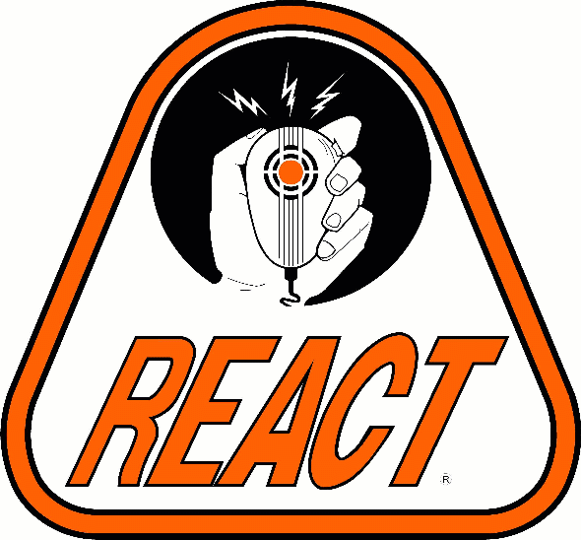

MEMBERSHIP

APPLICATION

REACT is a 501(c) (3) not for profit organization, with all volunteer members. All dues and many expenses of members are tax deductible.
Membership is open to all interested persons who complete this application, pay the specified dues, and meet the requirements of membership, as specified in the Team’ s bylaws and corporate charter.

There is no requirement, (condition of membership) for applicants nor members to hold any specia1 radio 1icenses, although many members have obtained amateur, GMRS, and other licenses in order to further their personal abilities to communicate.

The information you provide on this application will be kept confidential by the REACT Team’s Board of Directors. This application becomes the property of the REACT Team and will not be returned. Willful falsification of information on this application will be reasonable grounds for termination of membership. All ne3w members are on automatic 60 days probationary period. A copy of the REACT Team’s bylaws will be made available upon request. The Minimum age to join REACT is 14 years old for Junior Members and 18 years old for Adult Members. There is no maximum age limit to membership. There will be no discrimination based upon age, sex, religion, or ethnic origin.
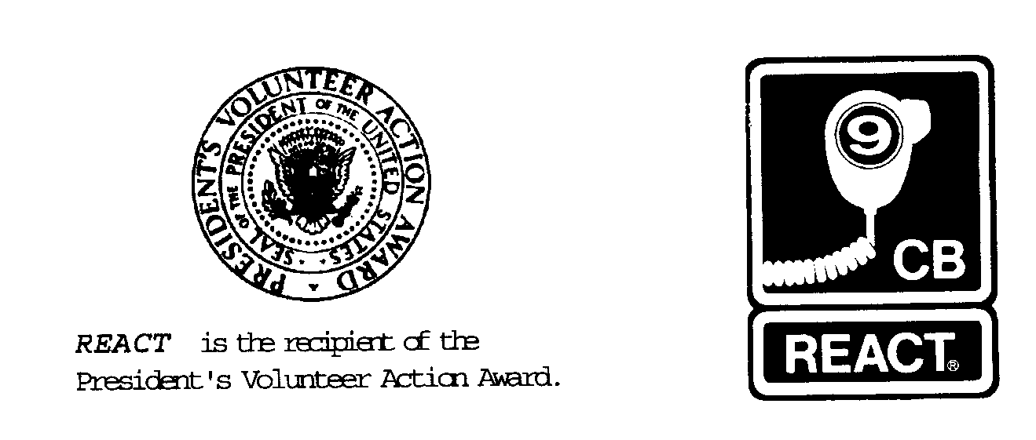

“Providing public service through radio communications since 1962”

Please Type or Print neatly on this Membership Application. (All fields must be filled in or marked N/A of not applicable)
Personal Information: This information is required. Please fill in all fields or mark N/A if not applicable.
Name (Last Name, First Name, Middle Initial

Social Security Number

Age:

Address:

E-mail Address:

City State Zip

Home Phone: (Note if unlisted)

Work Phone: (*See Employment info)

Other: (Cell, Pager, etc.)

Birth Date MM/DD/YYYY

Sex: Optional Male
Female
Marital Status: Optional Married
Single
Spouses name: Optional

Drivers License and Vehicle Insurance Information: The state of Maryland requires that all motorists have a valid drivers license and proof of insurance. Since many of our official activities require driving your personal vehicle, it is necessary for us to ask you for this information. Failure to supply this information will not affect your application for membership.
Drivers License number:

State:

Expiration Date:

Insurance Company / Agent Name and Phone number:

Expiration Date:

Policy Type: Comprehensive
Liability Only
Vehicle #1: 2x4 4x4 (4x4 required for winter weather transport)

Make: _______________________________________________________

Model: ______________________________________________________

Year: ______________ Color: ___________________________________
Vehicle #2: 2x4 4x4 (4x4 required for winter weather transport)

Make: _______________________________________________________

Model: ______________________________________________________

Year: ______________ Color: ___________________________________
Employment Information: It is the REACT Policy Not to release work locations or phone numbers without prior permission from the member involved, however it is of benefit to REACT to be aware of where our members are employed, to avoid cases of “Conflict of Interest” that could jeopardize a members employment or REACT Internationals IRS non-profit status. Failure to supply this information will not affect application for membership

Employer:

Position:

Address:

City:

State and Zip Code:

Radio Information: Since REACT is a radio-oriented organization, it is important for us to know what radio background you might have, and what radio equipment you have access to. Failure to supply this information will not affect your application for membership

Citizen Band (CB) Radio: Base Units: ________ Mobile Units: ________ Hand Held Units: ________ FRS Units: ________

Licensed Amateur: YES NO If Yes, Call Sign is:__________________ License Class: ____________ Code: Y N

Licensed GMRS: YES NO If Yes, Call Sign is:____________________ Expiration Date: __________ Repeater: Y N

Name (Last Name, First Name, Middle Initial
Social Security Number

Shirt Size:

S M L XL XX XXX

Other Organizations affiliated with: Due to the multitude of other agencies and/or organizations that REACT works closely with, it is important for us to know what other affiliations you may have with other organizations or agencies. This information will enable us to determine the amount of time that you may be able to contribute as a member of REACT in a time of emergency. For Example belonging to a volunteer fire department may cause conflict if REACT is called out at the same time to help with the fire fighting efforts. Your duties as a fire fighter may take priority over those in REACT, thus making you unavailable at times. REACT does not expect its’ members to be available 100% of the time and realizes that there are times when Family, church, employment, or other obligations may take priority over REACT Team meetings or activities.
Name:

Purpose:

Your Position:

Name:

Purpose:

Your Position:

Your Position:

Name:

Personal References: REACT Membership carries a heavy responsibility. Our members must be able to work closely with law enforcement officers, emergency responders, and the general public in a position of trust and responsibility. This is the reason for requiring three (3) non-family character references. Failure to provide this information will result in immediate rejection of this application for membership

Purpose:

Reason for joining REACT: Briefly state why you wish to become a REACT member. Failure to supply this information will not affect your application for membership

Special Skills:

Discloser and membership agreement notice: The information contained in this application will remain confidential, and will not be released outside of the board of directors without the permission of the applicant other then for use in official team rosters or registration and/or for insurance purposes. By signing this application you are giving REACT explicit permission to contact references that you have provided, and to conduct a background check with local law enforcement agencies (at REACT expense). No medical exams are required. The results of any such investigation may become part of this application. If you are holding a valid radio operators license you are requested to attach a copy of said license to this application. In the event of acceptance, you agree to follow the rules and regulations outlined in the team’s bylaws (as may be amended by the membership), and will conduct yourself in such a manner as to not reflect unfavorably upon the REACT Team. You will be on probation for 60 days following acceptance of this application, and payment of dues. You certify that all answers given on this application are true and accurate to the best of your knowledge. This is not an application for nor and offer of employment with REACT, and is not a contract of membership. Acceptance is dependant upon a vote by the current membership at a regular membership meeting.

Signature of applicant: _________________________________________ Print Name: __________________________________________Date:___________
Name:

Address:

Telephone:

Name:

Address:

Telephone:

Name:

Address:

Telephone:

Sponsor:

Annual REACT International Dues 20.00
REACT International Insurance: $6

Dues can be paid by assisting the team in raising funds.

This Portion of the Application must be completed.

