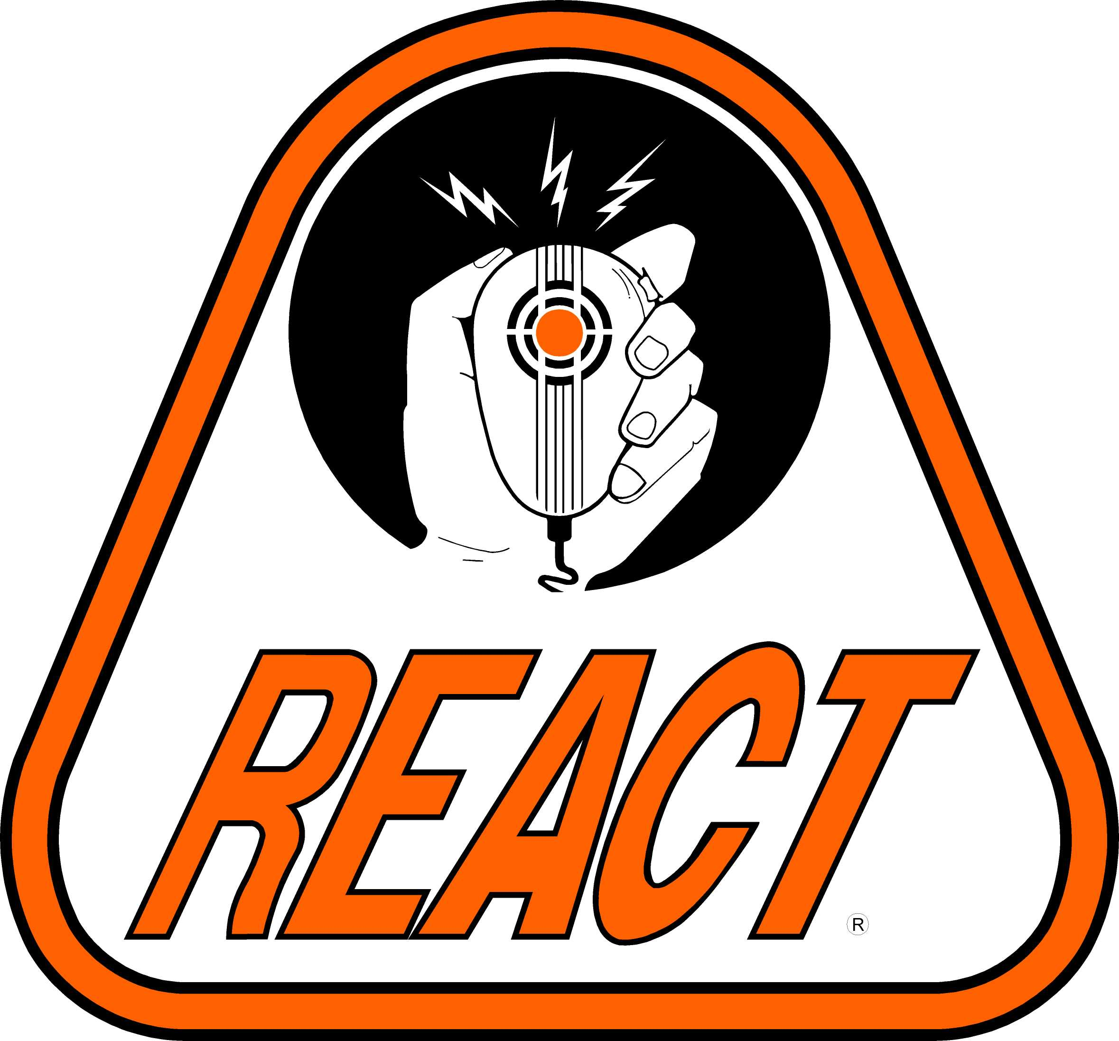
Baltimore REACT – Team 6033
5728 Richardson Mews Square
Baltimore, Maryland 21227
(443) 277-9512
baltimorereact.org

Monday, January 31, 2005

NEWS RELEASE

"HOWARD COUNTY REACT CHANGES NAME, COVERAGE AREA"

BALTIMORE METRO REACT (BALTIMORE, MD) – Today, HOWARD COUNTY REACT, a volunteer, not-for-profit organization, specializing in emergency, two-way communications has moved it’s operations closer to the Baltimore metro region and as a result of this move has officially changed it’s charter with REACT International. The new name, BALTIMORE METRO REACT, has been established to fill a need for 2-way radio communications during disasters as well as other special community events such as parades, runs, walk-a-thons, bike tours, and other related events in the Baltimore metro area where 2-way communications are essential to the success of the event. As part of these changes, BALTIMORE REACT plans to be involved in disaster preparedness events that test the local area’s ability to respond to disasters.

BALTIMORE METRO REACT also plans to work with local authorities in establishing a Memorandum of Understanding to prepare for future disasters or special events.

These local authorities include:
- The Baltimore City/County Chief Executive’s Office
- Baltimore City/County Police, Sheriff, Fire & Rescue
- Maryland State Police
- American Red Cross of Central Maryland
- Salvation Army
- And other local authorities

Achieving these goals requires additional members and BALTIMORE METRO REACT is activity seeking new members. If you are interested in joining BALTIMORE METRO REACT, please contact the Public Information Officer listed below. As the team becomes more established in the area, BALTIMORE METRO REACT will hold meetings on a regular basis. Please stay tuned for additional releases for meeting dates and times as well as other team activities and events.

For additional information, contact:

David Perry
Public Information Officer
Phone:(443) 277-9508

-----------------------------------------------------------------------
[About BALTIMORE METRO REACT]
Officially chartered by REACT International Inc. of Suitland, Maryland, BALTIMORE REACT supports our local community by providing emergency communications and assistance as requested by local authorities. Members purchase & maintain their own equipment to: (1) participate in training sessions; (2) improve radio proficiency to maintain readiness; (3) conduct field operations in support of community and special events; and (4) provide Public Service via Voluntary Two-Way Radio Communications. In most cases, the cost associated with travel and operations is absorbed by our member volunteers.

